**Excel Assignment – 6**

**1. What are the various elements of the Excel interface? Describe how they're used.**

**Ans:** The Excel interface consists of the following elements:

1. The **Quick Access Toolbar** is intended to group together the most frequently used commands. You can add or remove commands from this bar. To do this, click on the arrow on the right and select the required commands.
2. The **Ribbon** constitutes the general menu of the software. The ribbon is made up of tabs.  
   The **tabs** displayed by default are the File, Home, Insert, Page Layout, Formulas, Data, Review, View, and Help tabs.  
   Each tab displays **Command Buttons** grouped into **Command Groups**. The groups for the Home tab for example are: Clipboard, Font, Alignment, Number, Styles, Cells, and Editing.  
   **Dialog box launcher** are the buttons at the bottom right of a few groups. Each opens a dialog with additional options.
3. The **Name Box** displays the address of the active cell. You can also use it to access a cell; to do this, enter the address of the desired cell and validate with the "**Enter**" key.
4. The **Formula Bar** displays the content of the active cell.
5. Each Excel file is called a **Workbook**. A workbook is made up of one or more **Worksheets**. You can add a sheet using the **New sheet** button.
6. A **Cell** is the intersection of a column and a row. A worksheet contains 1,048,576 rows and 16,384 columns.

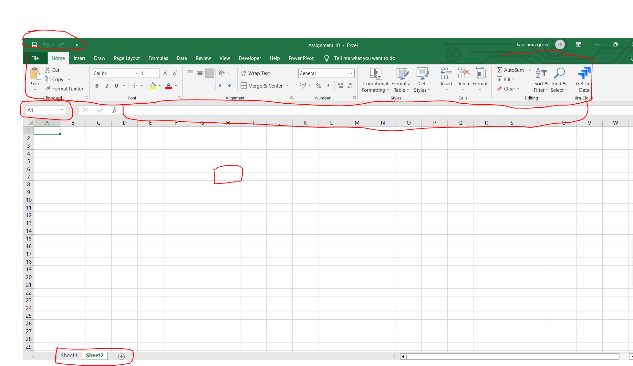

**2. Write down the various applications of Excel in the industry.**

**Ans:** Here are the various application Excel is used for:

1. Calculation: In order to make any sort of computation or use any formula to get a desired result, excel allows you to make calculations.
2. Accounting: Budget planning, forecasting, expense tracking, financial reports, loan calculation, and more. Excel can do all and meet all accounting needs.
3. Charting: There are a lot of chats that excel can offer- line charts, pie charts, scatter charts, bar charts, column charts, etc. If you need to find a way to represent data in a more visual and digestible way. Excel’s ability to transform rows and columns of digits into beautiful charts is one of the best options.
4. Inventory Tracking: Excel helps a lot of businesses, employees individuals organize inventory before a major problem comes up.
5. Calendars & Schedule: Excel is extremely robust as it helps to create a lesson plan for classes in schools and colleges, a PTO schedule for all co-workers, and a Daily schedule for a family, here are a lot of ways that this option is used in excel.
6. Seating charts: From large corporate events to wedding seating arrangements, excel can provide a seating chart using a spreadsheet of RSVPs.
7. Goal Planning worksheet: From professional goals to fitness goals to financial goals, it helps to have something to keep you focused and on track. Enter the beauty of Excel. Using the tool, you can create various worksheets, logs, and planning documents to help you monitor your progress—and, hopefully, cross the finish line.
8. Mock Ups: Excel might not be the first platform you think of when it comes to design. But, believe it or not, you can use the tool to put together various mock-ups and prototypes. In fact, it’s a surprisingly popular choice for creating website wireframes and dashboards.
9. Task List and Checklist: Excel provides both options and can be used really effectively, like for using grocery shopping or Taks provided by the manager.

Project management charts: We’ve already touched on the fact that Excel is a total beast when it comes to creating charts. And, this concept holds true when it comes to various charts for project management.

From waterfall charts to manage your team’s progress to kanban style boards (just like Trello!) to keep things organized, there are tons of ways that Excel can help keep your project on track.

1. Time logs: Excel help in tracking the time and making things more productive
2. Forms and Quizzes: Forms are used in various reporting tasks in various organizations, it can be events, education, IT, Agriculture, FMCG, etc.
3. CRM: Need a lightweight CRM to stay top of mind for your customers? You can make one in Excel. And, the best part? Building your own means it will be totally customizable. Sales Hacker also put together a nifty set of free sales excel templates you can use to help get started!

**3. On the ribbon, make a new tab. Add some different groups, insert commands in the groups, and name them according to the commands added. Copy and paste the screenshot of the steps you followed.**

**Ans**: Here are the following steps:

1. Right-click on the Excel **Ribbon**.  
2. Click on the **Customize the Ribbon**.

3. Click **New Tab** to insert a new tab.

4. Click on the **New Group option** at the bottom

5. Select the group and you will see an option appear from the Choose Command from where you can **Add** the commands by just clicking on the **Add** option in the center of both lists of options.

6. Right- click on one group and select **Add New Group** option, this is how multiple groups can be created and just add the command from the command options provide on the left side.

7 Once done all the above steps click on OK and then you can see your changes on your worksheet.  
  
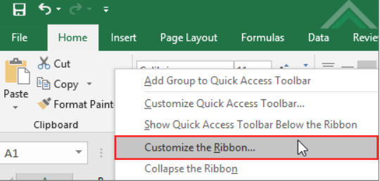  
  
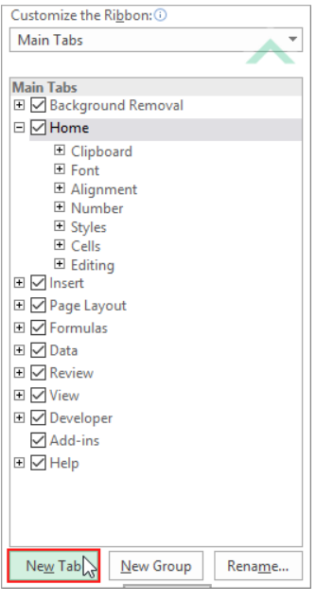

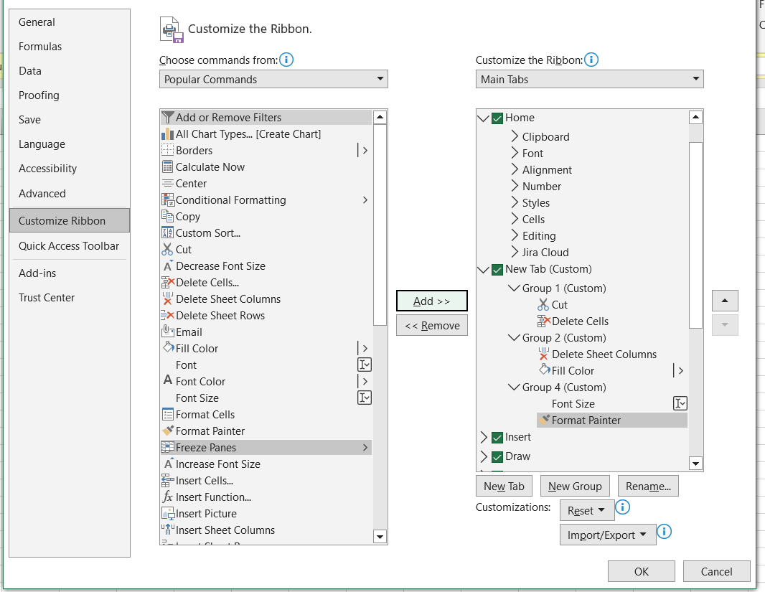

**4. Make a list of different shortcut keys that are only connected to formatting with their functions.**

**Ans:** Here is the following list:

|  |  |
| --- | --- |
| **Format data by using shortcut keys** | |
| Display the Style command (Format menu) | ALT+' (APOSTROPHE) |
| Display the Cells command (Format menu) | CTRL+1 |
| Apply the General number format | CTRL+SHIFT+~ |
| Apply the Currency format with two decimal places (negative numbers appear in parentheses) | CTRL+SHIFT+$ |
| Apply the Percentage format with no decimal places | CTRL+SHIFT+% |
| Apply the Exponential number format with two decimal places | CTRL+SHIFT+^ |
| Apply the Date format with the day, month, and year | CTRL+SHIFT+# |
| Apply the Time format with the hour and minute, and indicate A.M. or P.M. | CTRL+SHIFT+@ |
| Apply the Number format with two decimal places, 1000 separator, and – for negative values | CTRL+SHIFT+! |
| Apply the outline border | CTRL+SHIFT+& |
| Remove all borders | CTRL+SHIFT+_ |
| Apply or remove bold formatting | CTRL+B |
| Apply or remove italic formatting | CTRL+I |
| Apply or remove an underline | CTRL+U |
| Apply or remove strikethrough formatting | CTRL+5 |
| Hide rows | CTRL+9 |
| Unhide rows | CTRL+SHIFT+( |
| Hide columns | CTRL+0 (ZERO) |
| Unhide columns | CTRL+SHIFT+) |

**5. What distinguishes Excel from other analytical tools?**

**Ans:** Excel is a powerful analytical tool that is widely used in various industries for data analysis, financial modeling, and business forecasting. Some of the key features that distinguish Excel from other analytical tools includes

1. User-friendly interface: Excel has a user-friendly interface that allows users to perform complex calculations, create charts, and graphs, and manipulate large amounts of data with ease.
2. Versatility: It's versatile and can be used for a wide range of applications, including data analysis, financial modeling, budgeting, forecasting, and project management.
3. Data management: Allows users to manage and manipulate large amounts of data with ease, including filtering, sorting, and grouping data.
4. Formula functionality: Excel has a vast range of built-in formulas and functions that can perform complex calculations, including statistical and financial calculations.
5. Graphical representation: Excel provides a range of tools to create graphs, charts, and other visual representations of data, making it easy to understand and analyze large data sets.
6. Automation: Excel allows users to automate repetitive tasks using macros and scripts, saving time and improving efficiency.
7. Integration: Excel can easily integrate with other Microsoft Office tools, such as Word and PowerPoint, as well as third-party software tools, making it a powerful and versatile analytical tool.

**6. Create a table and add a custom header and footer to your table**

**Ans:** 